Dina Ibrahim by Andrew Roberts

Asylum magazine 24.2. June 2017

Dina Ibrahim loved the Sudanese sun burning down on the river Nile as much as I love grey English mists. Born in Africa in 1981, she was buried there in February 2017. Although living in London since her early teens, she retained strong links with the Sudan and with Ahfad University for Women which developed from a girls' school established in 1907 by her famous ancestor Babikir Badri. Only 35 when she died, Dina was one of the youngest active members of the London Survivors History Group. She had planned to come to our meeting in January 2017, but flew to Africa instead. Facebook's Arabic/English translations have linked family and friends together since her death, and her cousins Shahd and Mohamed came to our March meeting.

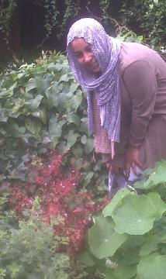
Dina experienced the world through a succession of deep depression and elation, but mostly depression. Although often exciting, her elation made her vulnerable, her depression, although awful, helped her relate to people like me. When her mental life prevented her attending our meetings, Dina remained engaged with us, on one occasion speaking to everyone via her mobile. Overcoming the problems of her mood swings, Dina graduated in Sociology from Middlesex University in 2012. She helped the Survivors History Group with a conference at the University and sold the Asylum relaunch issue at our "Pageant of Survivor History" event at Kingsley Hall in March 2010. A communal bus took us with Tower Hamlets African and Caribbean Mental Health Organisation to Birmingham to study "health through history" in 2010, and in 2014 Dina and her cousin Hagir joined in celebrating the life of survivor poet Howard Mingham.

In 2015 Dina wrote in a report on the paintings of Mary Barnes, "If I could have expressed what I was feeling so openly, I might have overcome a lot of issues". Dina had a gift of opening our eyes to things we might not have seen. She sought to share what it is to be a survivor in the Sudan and in London and we had some discussions about this at the Survivors History Group in which Hagir also took part. Dina suggested to me that we might explore what the world is through different cultures. At the Jewish feast of Tabernacles we were guests at the garden meal of friends. We went to the Eid celebrations of the Sudanese and Ummah Party Community in Wembley, and to a Quaker meeting. The picture shows Dina with a plant of Herb Robert whose foliage has turned red. We found purple, orange and red Herb Roberts in different parts of London. Colours reached out and held Dina, as they did the poet Charlotte Mew.

